
智能电表充值缴费操作指南
Charging and Payment Operation Guide for Intelligent Electric Meters
- 微信充值方式
Charging via WeChat
步骤1：打开微信通过右上角的“扫一扫”扫描下方的二维码或“添加朋友”的方式，搜索“电精灵”微信公众号，进入“电精灵”微信公众号
Step 1: Open WeChat and scan the QR code below via “Scanning” in the upper right corner of WeChat, or search the WeChat official account of “Electronic Wizard” by “adding friend” and enter the WeChat official account of “Electronic Wizard”
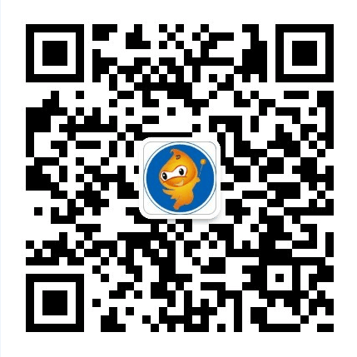
备注：电表安装完毕后，需约3天后方可通过微信进行充值缴费及查询功能，期间电表正常计量，不影响用电。
Notes: After the installation of the electric meter, it will take about 3 days before you can charge, pay and query through WeChat. During this period, the electric meter is normally measured, which does not affect the electricity consumption.
步骤2：进入公众号后
点击下方：服务-充值
Step 2: After entering the official account
Click below: Service - Charge

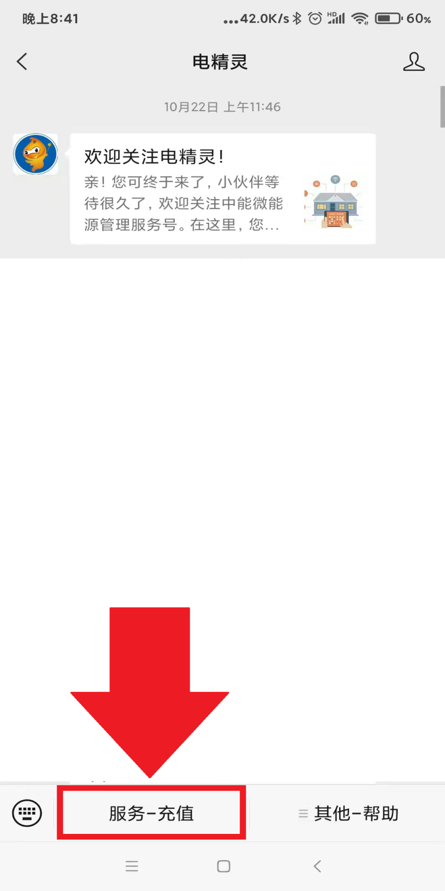

步骤3：选择：水电管理
Step 3: Select: Water and Electricity Management

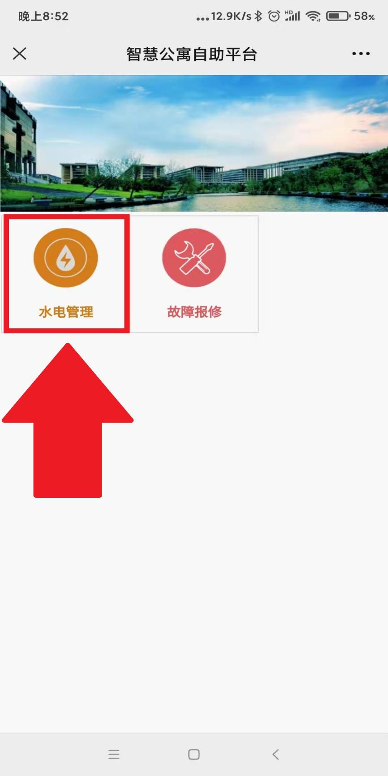

步骤4：选择区域
选择：北京师范大学珠海校区
Step 4: Area Selection
Select: Beijing Normal University at Zhuhai
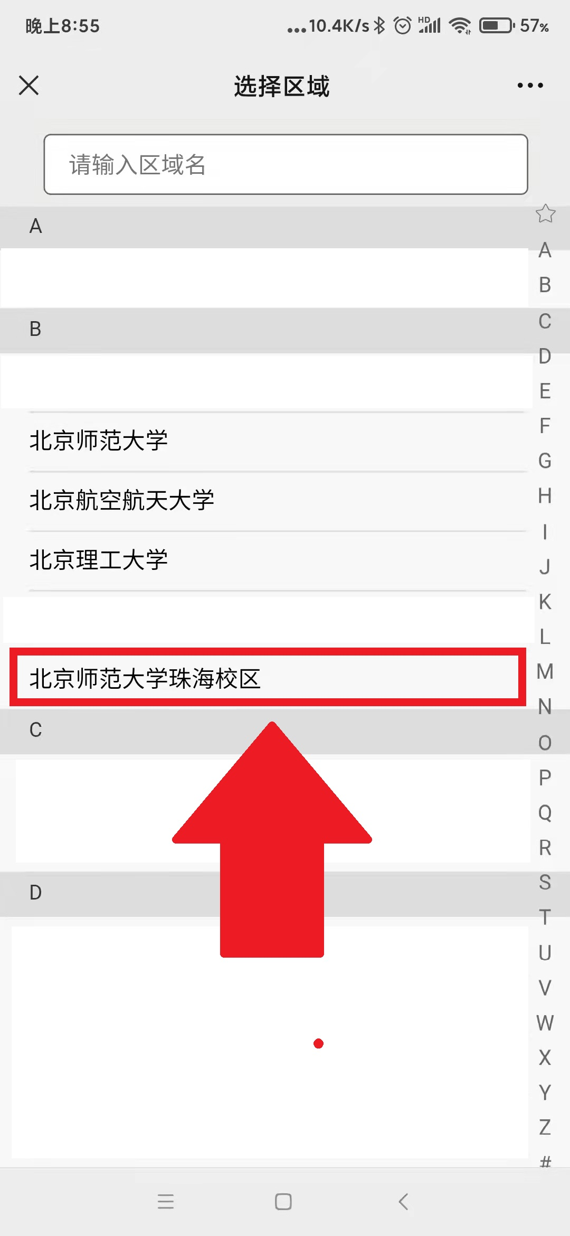

步骤5：身份认证：
请务必根据自己真实情况选择区域、建筑、楼层、房间，以免出现电费充到别人房间的情况。
Step 5: Identity Authentication
Please be sure to choose the area, building, floor and room according to your actual situation, so as to avoid charging electricity to other people’s rooms.
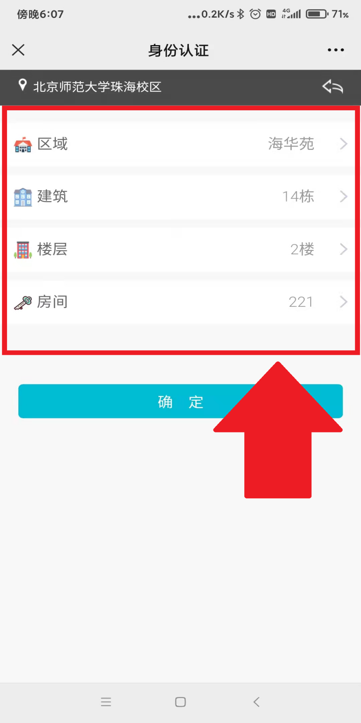

步骤6：绑定成功，这时可以看到当前房号下的电表及三大功能菜单。
Step 6: After successful binding, you can now see the electric meter and the three major function menus under the current room number.
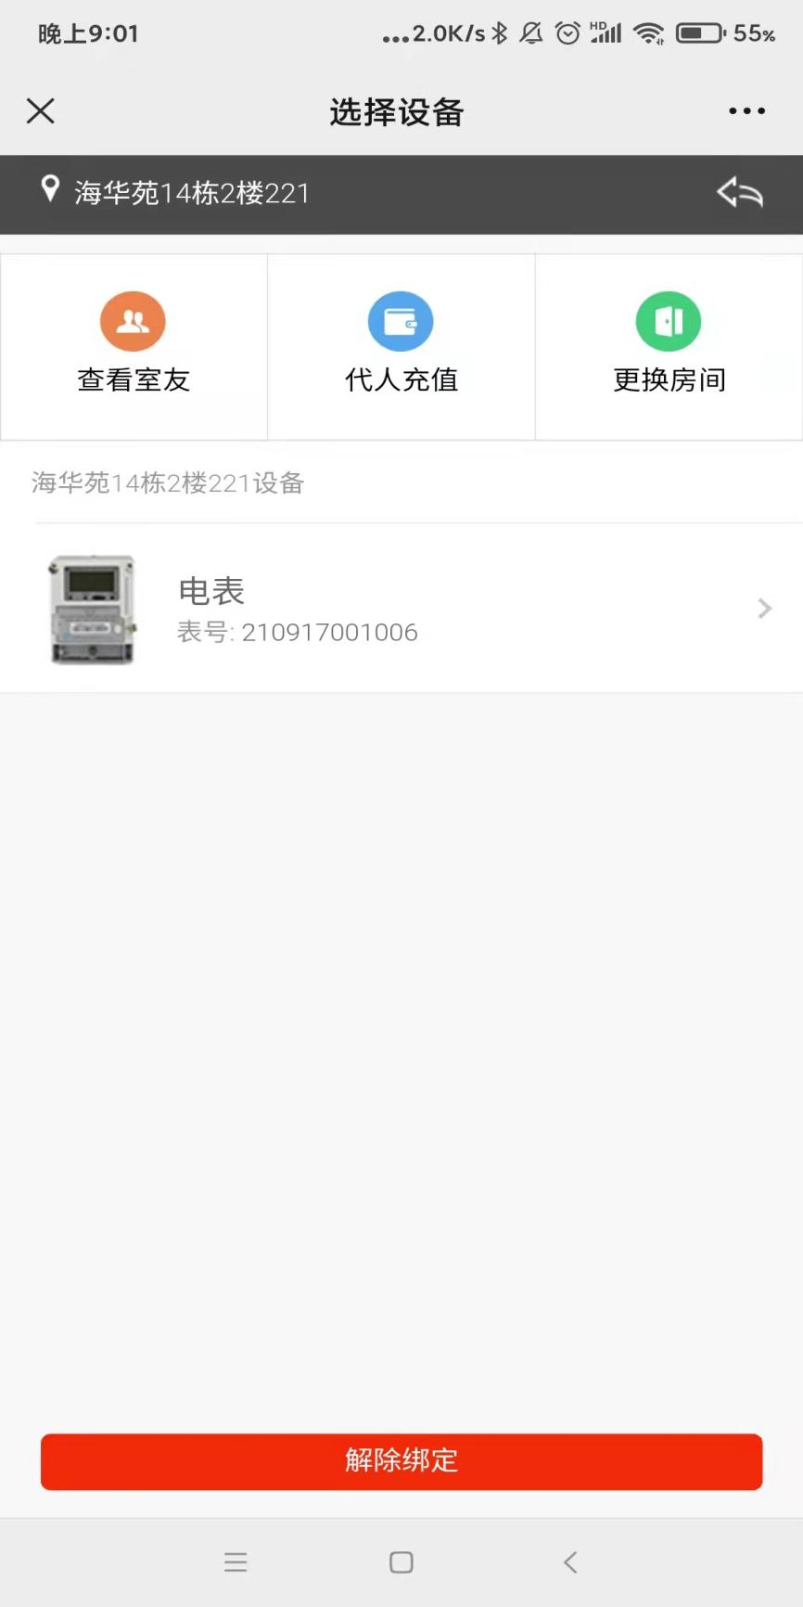
- 查看室友：查看同宿舍下其他绑定的用户 ；
- View roommates: View other users bound with the dormitory;
- 代人充值：可以为其他宿舍进行充值，不需要解绑自己的宿舍
- Charge for others: You can charge the electricity bill for other dormitories without unbinding your dormitory
- 更换房间：解除该宿舍绑定，重新绑定另外的宿舍，
每个账号限3次超过需要找管理员解禁次数；
- Change rooms: Unbind the dormitory and rebind another dormitory, which is limited to 3 times for each account. If it exceeds 3 times, you need to find the administrator to lift the ban;

步骤7：点击电表
Step 7: Click the electric meter

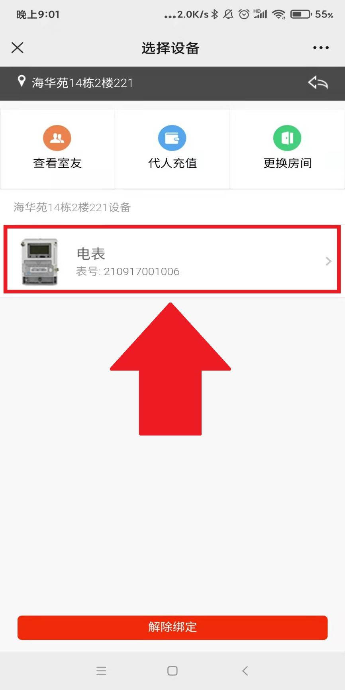

步骤8：进入电表信息/充值界面 这时可以看到关于用电的三种报表
Step 8: Enter the interface of electric meter information / charge
At this time, you can see three kinds of report about electricity consumption
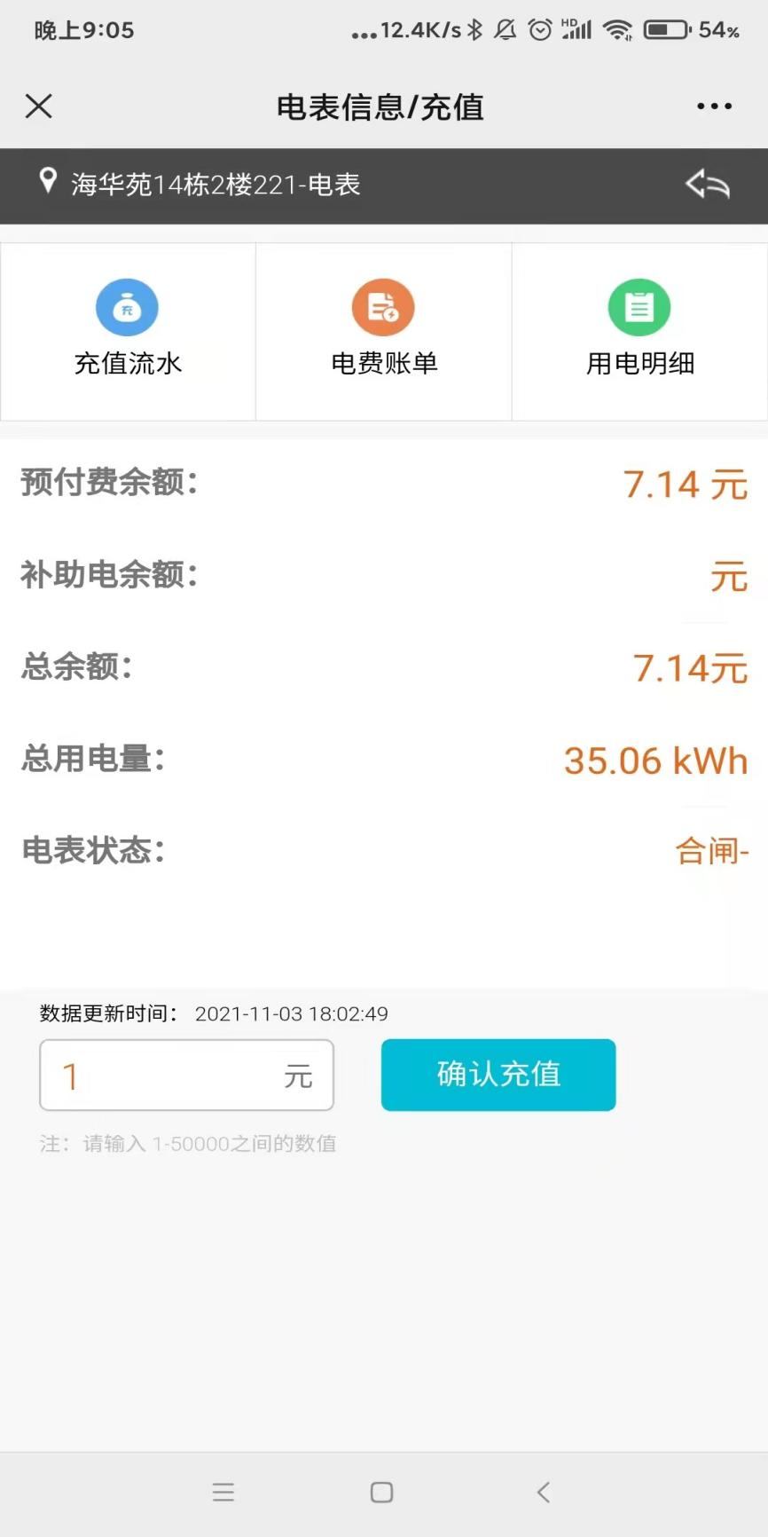
- 充值流水：该宿舍历史缴费情况；
- Charge record: The historical payment status of the dormitory
- 电费账单：可以查询每月的总用电量及用电金额；
- Electricity bill: You can query the monthly total electricity consumption and the amount of electricity consumption;
- 用电明细：可以查询每日的用电量、用电金额的明细；
- Electricity consumption details: You can query the daily electricity consumption and the details of the amount of electricity consumption;

步骤9：充值
点击对话框，输入金额，确定充值，假如房间已经欠费断电了，马上充值即可恢复宿舍用电
Step 9: Charge
Click the dialog box, enter the amount, and confirm the charging. If the room’s electricity bill is in arrears and the electricity is cut off, charge immediately to restore the dormitory’s electricity
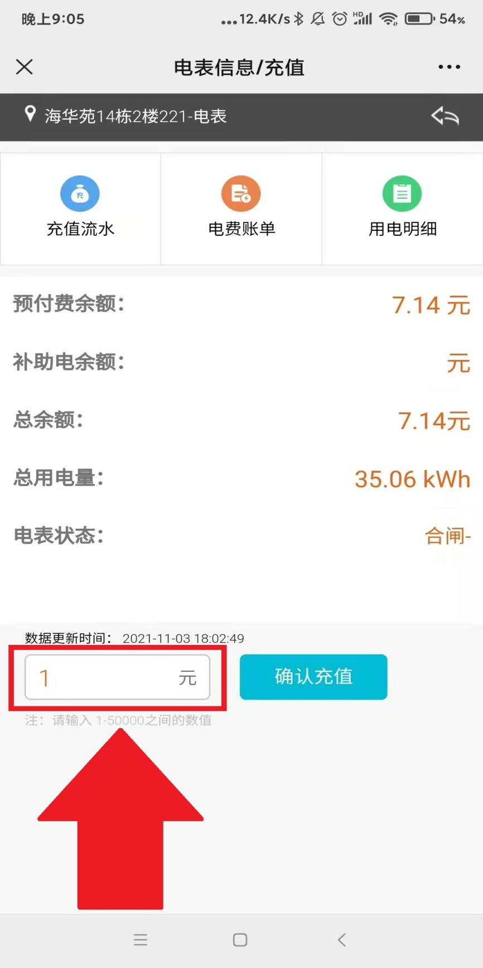

低余额提醒功能：
Function of low balance reminding:
- 主动推送功能。当账户可用余额低于30元时主动发生微信提醒。
- Active push. When the available balance of the account is less than 30 yuan, a WeChat reminder will occur voluntarily.
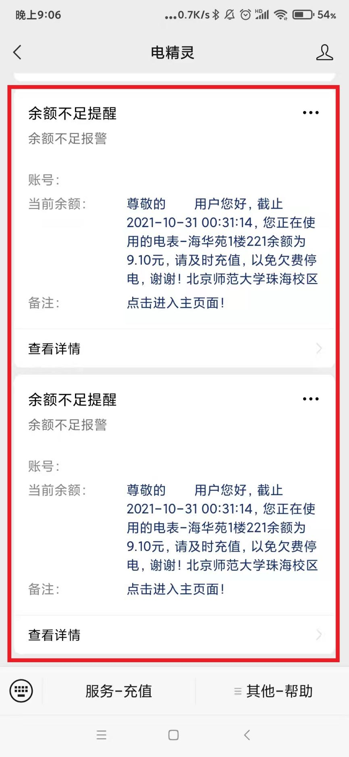
- 智能电表服务部现场充值方式
On-site Charging in Intelligent Electric Meter Service Department
- 可亲临粤华苑15栋学校智能电表服务部
现场通过POS机刷银行卡、信用卡充值购电
You can go to the intelligent electric meter service department of the school in Building 15, Yuehuayuan to charge and purchase electricity by swiping bank cards and credit cards through POS machines
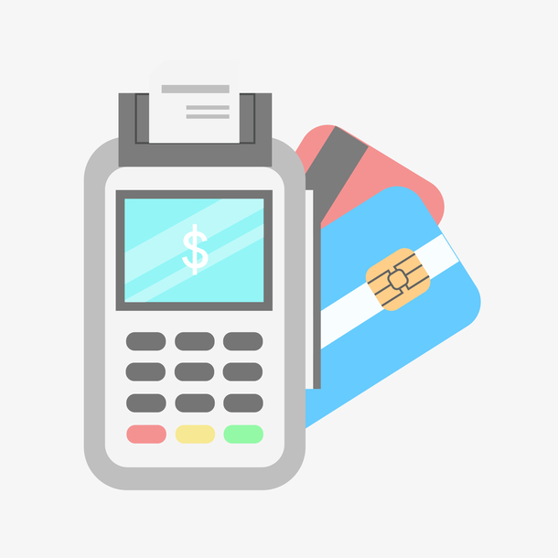
- 遇到疑问或者特殊故障，请参考以下方式反馈：
- In case of doubt or special failure, please feedback by the following methods:
- 微信充值主界面，在“意见建议”填写相关信息
- On the main interface of WeChat charging, fill in relevant information in “Opinions and Suggestions”
- 学校智能电表服务部热线：3621531 3621620
- Hotline of School Intelligent Electric Meter Service Department: 3621531 3621620
- 电话报故障24h工作人员处理热线：18607564105 方工
- 24-hour staff handling hotline for reporting failures by telephone: 18607564105 Mr. Fang

